SOCIAL POLICY EDUCATION:
WHERE ARE WE AND WHERE ARE WE HEADING?
A Day Conference co-organised by the Social Policy Association (SPA), the International Centre for Public and Social Policy (IcPSP), and Social Policy and Society (SPS)

10 am – 4 pm (on-site), 10:20 am to 1 pm (online on MS Teams),
Thursday, 16 April 2026
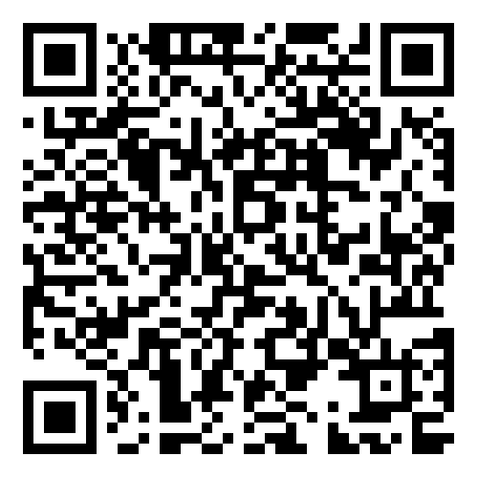

Jubilee Conference Centre, University of Nottingham
THE EVENT IS FREE. Registration is required via this link.
Registration deadline: 5 pm Thursday, 9 April 2026 (UK time)

An MS Teams link will be sent to online participants three days before the event.

Facilitators: Enrico Reuter (am), Ann-Marie Gray and Ruby Chau (pm)
Programme (provisional):
Time | Activities | Format
10:00-10:20 | Tea/coffee and networking | In-person
10:20-10:30 | Welcome and opening | Hybrid
10:30-11:30 | A report on the key findings and launch of the Research Report on Co-defining Social Policy and Social Policy Education (30-minute presentation followed by 30-minute Q&A)  - Ruby Chau and Sam Yu | Hybrid
11:30-13:00 | Social policy education in diverse forms: country-based experiences from (15-minute presentation for each case plus 10-minute Q&A and 10-minute open floor at the end)  - Hong Kong: Grace Ho (online)  - Australia: Laura Simpson Reeves (in person)  - Canada: Filipe Duarte (in person)  - Germany: Anna Hokema (in person) | Hybrid
13:00-14:00 | Lunch and networking | In-person
14:00-14:20 | Welcome back and Lightning Reflections on good practice or lessons to learn on contemporary themes (5 mins each)  - EDI and accessibility of disabled students: Dianne Theakstone and Lisa Davison  - Generative AI: Emily Ball  - Sustainability: Maria Franco Gavonel  - Employability and Entrepreneurship: Libby Steel | In-person
14:20-15:20 | Hot-desk SWOT analyses: participants can join the hot-desk discussion of up to two themes (30 mins each) facilitated by:  - EDI and accessibility of disabled students: Dianne Theakstone and Lisa Davison  - Generative AI: Emily Ball  - Sustainability: Maria Franco Gavonel  - Employability and Entrepreneurship: Libby Steel | In-person
15:20- 16:00 | Report back from hot-desk analyses, reflection on the day, planning for the next step and closing | In-person

Facilitators and speakers (by alphabetical order)
Dr Emily Ball, University of Birmingham, UK
Dr Ruby Chau, University of Nottingham, UK
Dr Lisa Davison, University of Stirling, UK
Dr Filipe Duarte, Catholic University of Portugal, Portugal
Dr Maria Franco Gavonel, University of York, UK
Professor Ann-Marie Gray, Ulster University, UK
Dr Grace Ho, Hong Kong Polytechnic University, Hong Kong SAR
Dr Anna Hokema, University of Bremen, Germany
Dr Laura Simpson Reeves, University of Queensland, Australia
Dr Enrico Reuter, University of York, UK
Libby Steel, University of Nottingham, UK
Dr Dianne Theakstone, University of Stirling, UK
Dr Sam Yu, University of Nottingham, UK.

Event volunteers
Claudia García
Clementine Law
Lisa Li
Clement Yu

